Ideonella Sakaiensis Trash System

We came up with a solution, the Ideonella Sakaiensis Trash system. This idea prevents the amount of waste plastic from growing. We do this through the Bacteria Ideonella Sakaiensis.
In this document your going to find out what the Ideonella Sakaiensis is, what it does, how it works, and about our solution: the ISTS
Also visit our website
https://istsystem.wordpress.com/

What is Ideonella Sakaiensis?

The Ideonella Sakaiensis consumes PET plastic. It leaves a substance behind which is similar to water, the water is not suitable for consumption.
The eating process takes a while. It can take up to 2 weeks for a PET plastic bottle covered with Ideonella Sakaiensis to decompose. You might think, this takes way to long. But when the bacteria eats, it multiplies itself. So the process will eventually go really fast.

How does the Ideonella Sakaiensis work?

The Ideonella Sakaiensis approaches the plastic and starts eating, while it eats, It leaves behind distilled water (H2O), but this isn’t drinkable because there are no minerals in it.

Facts about the bacteria:
- The bacteria grows best at 30-37 °C and 7.0-7.5 pH, but is able to survive between 15 °C and 42 °C and 5.5-9.0 pH.
- The water which is pumped out by the ideonella sakaiensis is chemically pure and thus not fit for drinking.
- The chemical formula for PET plastic is (C10H8O4)n.
- Nobody knows what the n at the end of the formula means.
- 4H2O is left after the plastic is eaten which is water.
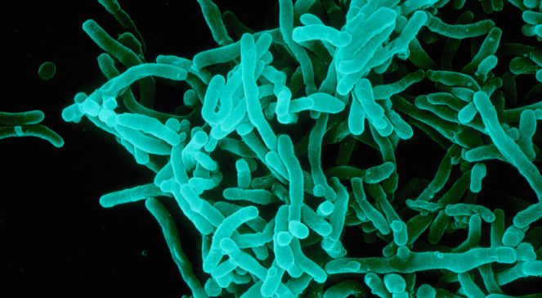

The Ideonella Sakaiensis Trash System (ISTS)

At first we wanted to come up with something to solve the plastic soup. But, because it is such a big problem, it is really hard to solve. So we wanted to prevent it from growing. Even if we gather plastic to recycle, an insane amount of it still does not actually get recycled, so we thought of a different solution. We thought of putting the plastic eating bacteria: Ideonella sakaiensis, in a container, eating plastic that came there through a shaft in or next to a building. But of course this is not possible for people in neighborhoods with detached houses. So there had to be sort of the same thing for people that aren’t living in flats or apartments.
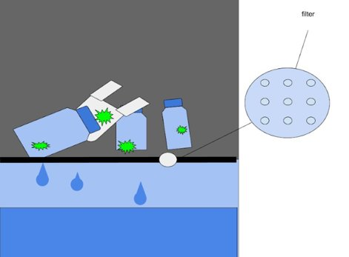
So we thought about using the same concept as a glass container (throw glass inside the container), only then we would put the bacteria inside a container and then people can throw the plastic inside the container.
The Ideonella sakaiensis leaves behind a substance which is similar to H2O. There will be a filter that filters out the plastic and lets the water pass through. After the process where the plastic is degraded the water is dirty because it might has touched other plastic that has not been cleaned before it has been thrown in the bin. So, that’s why we filter it.

In apartments and terraced houses this can be done in one big system, in houses which are not that close to each other they can have a small container in there home.
In apartments:
Every floor has an opening to a shaft which leads to a big container which has bacteria in it. This bacteria degrades PET plastic (that’s in bottles and plastic bags) to distilled water (H2O), but this isn’t drinkable because there are no minerals in it.
In neighborhoods:
In neighborhoods 2m × 2m × 1.5 containers with the bacteria (as described above) are put in place. The water produced by the bacteria in this containers is transported by pipes to a place where it can be put in the ground.

